Self-Evaluation Test. Roskin et alii Political Science. An Introduction.

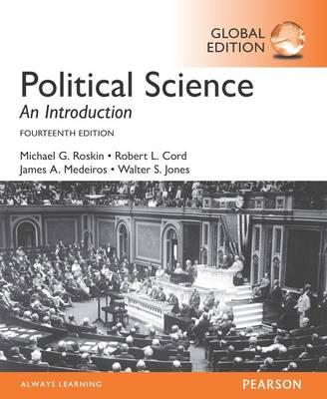

**Chapter 3. Ideologies**

What was Adam Smith’s main idea?

What is the origin of the term liberalism (as classic liberalism)

What is the origin of modern (American) liberalism?

What was Burke’s main idea?

What are the similarities between classic liberalism and modern conservatism?

What does it mean the “state is the problem rather than the solution”?

Why do liberals and socialists (and in general progressives) oppose this view?

What are the main tenets of Marx’s *The Capital?*

What is class struggle?

What is the difference between Socialism and Social democracy?

What was, according to Lenin the origin of imperialism?

What were the main features of Fascism and Nazism as ideologies?

What was Eurocommunism?

What are the key ideas of feminism?

Adam Smith is associated with __________.

a. fascism

b. neoconservatism

c. classic liberalism

d. socialism

An ideology consists of __________.

a. a set of plans to improve society

b. an open-ended commitment to a political party

c. a set of assumptions about how the world works

d. a theory that can be proved with empirical evidence

Which of the following best expresses the difference between political scientists and ideologues?

a. Political scientists argue for changes to political systems, while ideologues want to keep the system as it is.

b. Ideologues argue for changes to political systems, while political scientists want to keep the system as it is.

c. Political scientists are concerned with real conditions, while ideologues focus on how conditions should be.

d. Ideologues are concerned with real conditions, while political scientists focus on how conditions should be.

*The Wealth of Nations* was written by __________.

a. John Locke

b. Adam Smith

c. Edmund Burke

d. Anthony Downs

The *laissez-faire* viewpoint recommends __________.

a. creating monopolies to ensure efficiency

b. leaving the economy alone to promote growth

c. intervening heavily in the economy to promote stability

d. breaking up large banks to reduce risks to the financial system

Which of these ideas was first advanced by Adam Smith?

a. Human beings are fundamentally moral.

b. Self-interest can produce social benefits.

c. Governments have a role in preserving traditions.

d. The government is inherently hostile to individual rights.

A modern liberal would *most likely* support which of the following policy proposals?

a. Eliminate the minimum wage.

b. Cut taxes for top income earners.

c. Privatize the social security system.

d. Increase regulations on the banking sector.

Which of these figures is one of the founders of classic conservatism?

a. G.W.F. Hegel

b. Edmund Burke

c. Margaret Thatcher

d. Niccolo Machiavelli

Milton Friedman and Adam Smith both argued that __________.

a. markets function best when left alone

b. markets require regulation to function properly

c. a progressive tax system promotes freedom and equality

d. the minimum wage is needed to equalize the power of owners and workers

How do classic conservatives address the issue of change?

a. They believe that change should happen gradually rather than suddenly.

b. They believe that change is only positive if it happens through government action.

c. They argue that change should first occur at the elite level before spreading to the lower classes.

d. They believe that change driven by technological advancement is almost always beneficial to society.

*The Communist Manifesto* was written by __________.

a. Karl Marx

b. John Locke

c. Mao Zedong

d. Adam Smith

A Marxist utopia would include which of the following elements?

a. an equal distribution of wealth

b. unlimited economic liberty and property rights

c. government action to preserve traditional values

d. civil rights protections and extensive market regulation

Which of these is an assumption underlying feminism?

a. Gender roles and attitudes are socially conditioned.

b. Men and women are biologically predisposed to perform different social roles.

c. Individuals find their identities through family ties and unified national values.

d. The government has an important role to play in preserving traditional family values.